Microworld research case study 1: Space Shuttle Commander (Rieber, 1991)

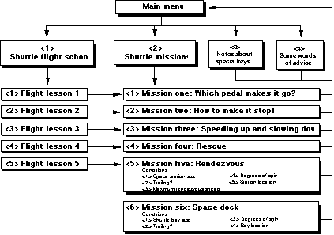
This software package is aimed at elementary and middle school students to help with a wide range of learning goals related to Newton’s laws of motion. Tutorials and a combination of gaming and simulations are employed to introduce learners to the laws of motion in nonmathematical ways. Students are given flight lessons (the tutorials) and allowed practice in maneuvering the space shuttle on missions (the gaming/simulation) in the process of learning and exploring Newton’s laws of motion. Space Shuttle Commander is designed to combine a hierarchical instructional framework (the tutorials) with constructivist exploration (the simulation).
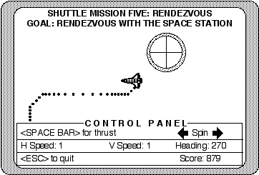
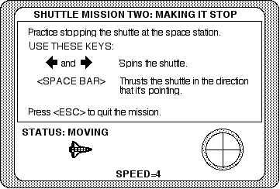

Carefully designed microworlds should encourage incidental learning. However, results of this study indicated that students who learn in incidental ways apply the information in a variety of contexts: some of which may be correctly applied to a larger set of learning goals; some of which may actually promote misconceptions.
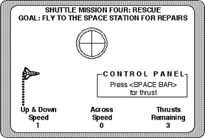
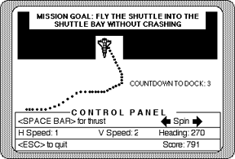

Results of this study emphasize the importance of some instructional guidance by a teacher or other expert. Although microworlds are designed to encourage constructivism and “discovery learning,” teachers are still needed to direct or redirect incidental learning to prevent it from becoming counterproductive.

Rieber, L. P. (1992). 'Computer-Based Microworlds: A Bridge Between Constructivism and Direct Instruction', Educational Technology Research and Development, 40(1): 93–106.

Extract from: Hogle, J. (1995). Computer Microworlds in education: Catching up with Danny Dunn.
(ERIC Document Reproduction Service No. ED 425738). [http://eric.ed.gov/?id=ED425738]
Microworld research case study 2: Green Globs and TGEO (Edwards, 1992)

Edwards’ studies tested the hypothesis that there exists common patterns of learning and interaction, and that students would make use of the debugging quality of microworlds to refine and correct their mathematical understandings while playing the games.
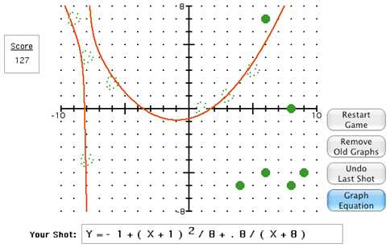
Edwards’ first study examined learner interaction with graphing equation software designed by Dugdale and Kibbey (1981), call Green Globs. This game links symbolic representation of an algebraic equation with its graph. The program displays a set of large dots scattered over a coordinate grid. Students type in an equation and the corresponding graph is drawn on the grid. The goal is to formulate an equation which will pass through as many dots as possible. Students in the study were able to use the visual feedback from the game to refine and correct their understanding of the algebraic functions.

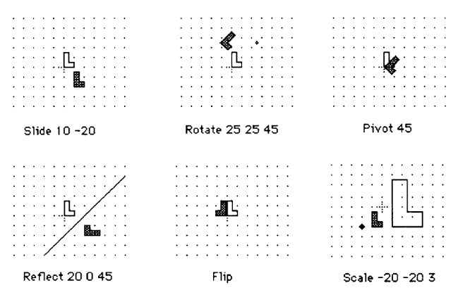
The second study used a LOGO-based microworld for transformational geometry, called TGEO. Students type in the specifications for a set of geometric transformations such as rotations, reflections, and translations, and see the effect of the transformation displayed on the computer screen. This microworld included a game, called The Match Game, in which the goal was to superimpose two congruent shapes by applying a sequence of transformations to one of the shapes.

Both the Green Globs and TGEO microworlds were designed to support children’s debugging of their own solutions, and to reconstruct their own mental models of the mathematical concepts presented in the environment. Results of the studies did suggest that the microworlds were effective in assisting students to gain a working knowledge of the mathematical models. Qualitative results indicated changes in the students’ thinking as well as changes in strategies for solving problems.

Edwards, L. D. (1992). 'A Comparison of Children's Learning in Two Interactive Computer Environments', Journal of Mathematical Behaviour 11: 73-81

Extract from: Hogle, J. (1995). Computer Microworlds in education: Catching up with Danny Dunn.
(ERIC Document Reproduction Service No. ED 425738). [http://eric.ed.gov/?id=ED425738]

Microworld research case study 3: Island Survivors
(Martin, Shirley, and McGinnis, 1987)

This study, aimed at upper elementary school students, examined their experience with an ecosystem microworld to speculate on the relationship of such learning environments to regular instruction.
Software used for the experimental group was Island Survivors (Rhineholt and Winston, 1985). The aim of the game is to help 3 shipwrecked humans live on an island for a year without disturbing the ecological balance of the island’s plant and animal species. The control group used other software which did not cover the concepts presented in the Island Survivors game. Both groups received classroom instruction and participated in field trips related to principles of ecosystems.

Results showed some transfer of microworld concepts to other settings, as well as application of some teacher-taught material among students who had experience with the model ecological system. The conceptual gains were most clear when children worked in small-group settings, as they had when they interacted around the microworld. The teacher described gains to her own instruction from the microworld, because the children’s talk about the game provided conceptual bridges to the material she had introduced.

Martin, L. M. W., Shirley, M., & McGinnis, M. (1987). Microworlds to Macroworlds: Conceptual Transfer and Activity Setting (Technical Report No. 46). New York:Bank Street College of Education, Center for Children and Technology. (ERIC Document Reproduction Service No. ED 319 379)

Extract from: Hogle, J. (1995). Computer Microworlds in education: Catching up with Danny Dunn.
(ERIC Document Reproduction Service No. ED 425738). [http://eric.ed.gov/?id=ED425738]

